# Graph Databases Educational Workshop Proposal

A graph databases is a type of software that stores information as nodes connected by edges. One familiar example of a network graph is a social network, where people are the nodes, and their friendships represent the edges. Any data set where connections are important could be a good use case for a graph database.

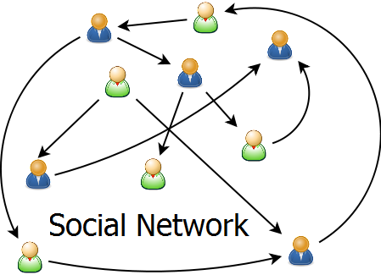

[This Photo](http://theglobalfool.com/facebook-high-connection-and-low-well-being/) by Unknown Author is licensed under [CC BY-NC](https://creativecommons.org/licenses/by-nc/3.0/)

[The Kansas City Graph Databases Meetup](https://www.meetup.com/Kansas-City-Graph-Databases-Meetup-Group/) is a group of professionals that meet monthly for educational events on topics related to graph database technology. We would like to partner with a local school to present an educational workshop for students in 4th through 8th grade.

The workshop could last approximately one hour. Three to six adults from the Meetup participate in the workshop. Some possible activities are included below. A team from KC Graph Databases Meetup would meet with the teachers to select two or three of these activities or design tailored to the students’ needs.

## How I use math every day

The adults from KC Graph Databases Meetup use math every day at work. Adult volunteers will briefly describe their jobs and how math helps them accomplish their work.

## Marshmallow graphs

Students create graphs with marshmallows representing the nodes and toothpicks representing the edges. Adults volunteers work with students to answer questions like the following.

* How many edges does each node in your graph have? Make a table to show your answer.
* How many triangles are in your graph?
* Which edge is part of the most triangles?
* Which edges could you remove to separate your graph into multiple parts?

## The Seven Bridges of Konigsberg

Leonhard Euler was a Swiss mathematician who invented graph theory in the 1700s. He started thinking about graphs when he visited the city of Konigsberg. There were seven bridges that crossed the rivers of the city. He wondered if he could take a walk around Konigsberg that would cross each of the bridges exactly once. Adults will work with small groups of students to try to draw their own paths on a map of Konigsberg. Groups will also try finding paths through other simple maps and see what patterns we notice. <https://www.mathsisfun.com/activity/seven-bridges-konigsberg.html>

## Exploring a food web

Adults work with students in small groups to explore a food web represented in a graph database. The groups could use laptops provided by KC Graph Database Meetup or school computers using a free website. Groups could use the graph to answer questions like “If a member of the food web disappeared, what plants and animals would be most impacted?” Groups can add new plants or animals to the graph based on their prior knowledge or research during the workshop.

## Graph a story

Adult volunteers will demonstrate a graph showing how characters in a book are related to each other. Groups of students will work with an adult volunteer to create a graph based on a book or movie that they are familiar with. Nodes in the graph can represent characters, settings, and events in the plot. Relationships will show how nodes are connected. Groups of students will create their graphs with pencil and paper. If time permits, the adult will help students enter their graph into a graph database.